This is likely an early representation of spiritual knowledge coupled with the ancient knowledge of neuroscience. I wish to bring these ancient cosmologies in light of modern knowledge of neuroscience, and to elevate them using the knowledge of the Quran.
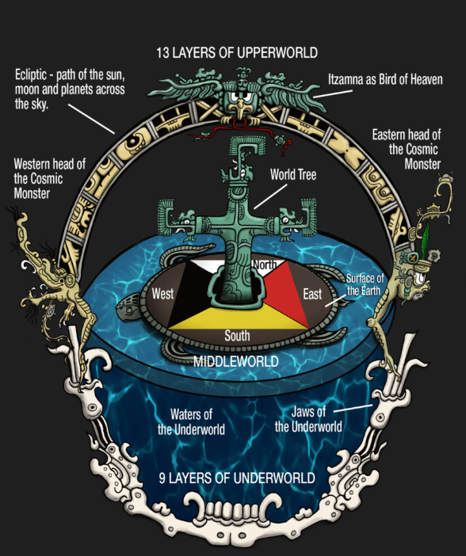 | 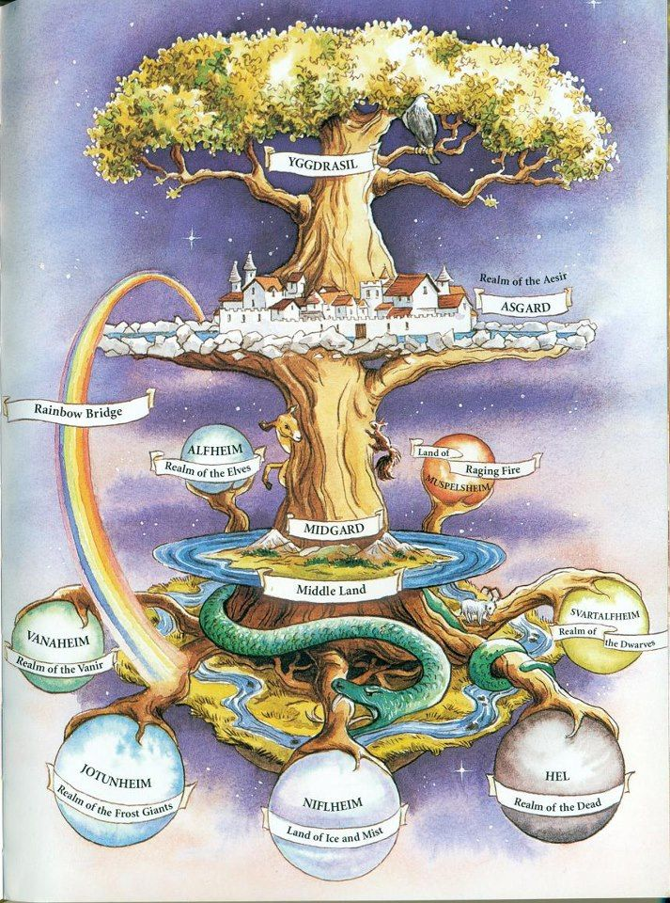
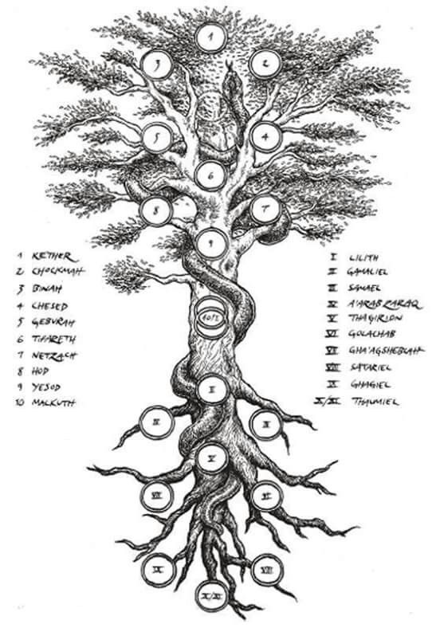 | 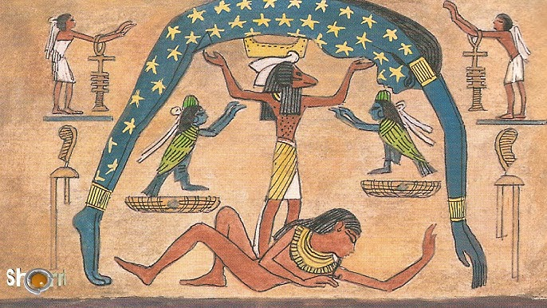
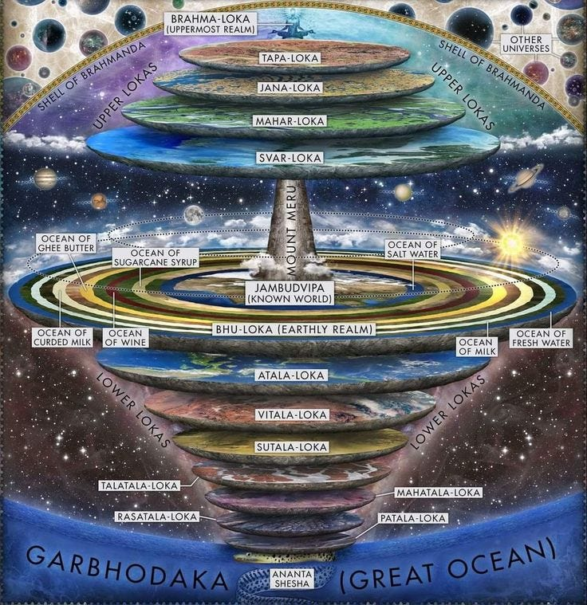

Which parts of the brain relate to the modes of operation Daniel Kahneman called thinking fast and slow?
System 1 – “Thinking Fast”
This mode is automatic, intuitive, effortless. It draws from:
- Amygdala – emotional reactions, threat detection
- Basal ganglia – learned habits and procedural shortcuts
- Posterior cortex (especially visual and sensory association areas) – rapid pattern recognition
- Ventral striatum – reward-based decisions
- Default Mode Network (DMN) (in some interpretations) – automatic, self-referential processing
These regions operate subconsciously, relying on heuristics, emotions, and speed over accuracy.
System 2 – “Thinking Slow”
This is deliberate, effortful, analytical. It engages:
- Dorsolateral prefrontal cortex (DLPFC) – reasoning, working memory
- Anterior cingulate cortex (ACC) – conflict monitoring, error detection
- Parietal cortex – abstract reasoning, number processing
- Hippocampus – memory recall in planning
- Frontal pole – metacognition, goal-directed control
This system is energy-intensive and slow—used when we override gut instincts or solve novel problems.

